­

Department of Computer Science and Engineering

Course Code: CSE350

Course Title: Data Communication

Section: 02

Semester: Summer 2024

Mini Project

Submitted to:

Md. Khalid Mahbub Khan

Lecturer

Department of Computer Science and Engineering

Submitted by:

Name: B. M. Shahria Alam

ID: 2021-3-60-016

Date of submission: 22nd September 2024

**Design a complete model of a complex network by discovering the interconnectivity of the systems.**

**Diagram:**

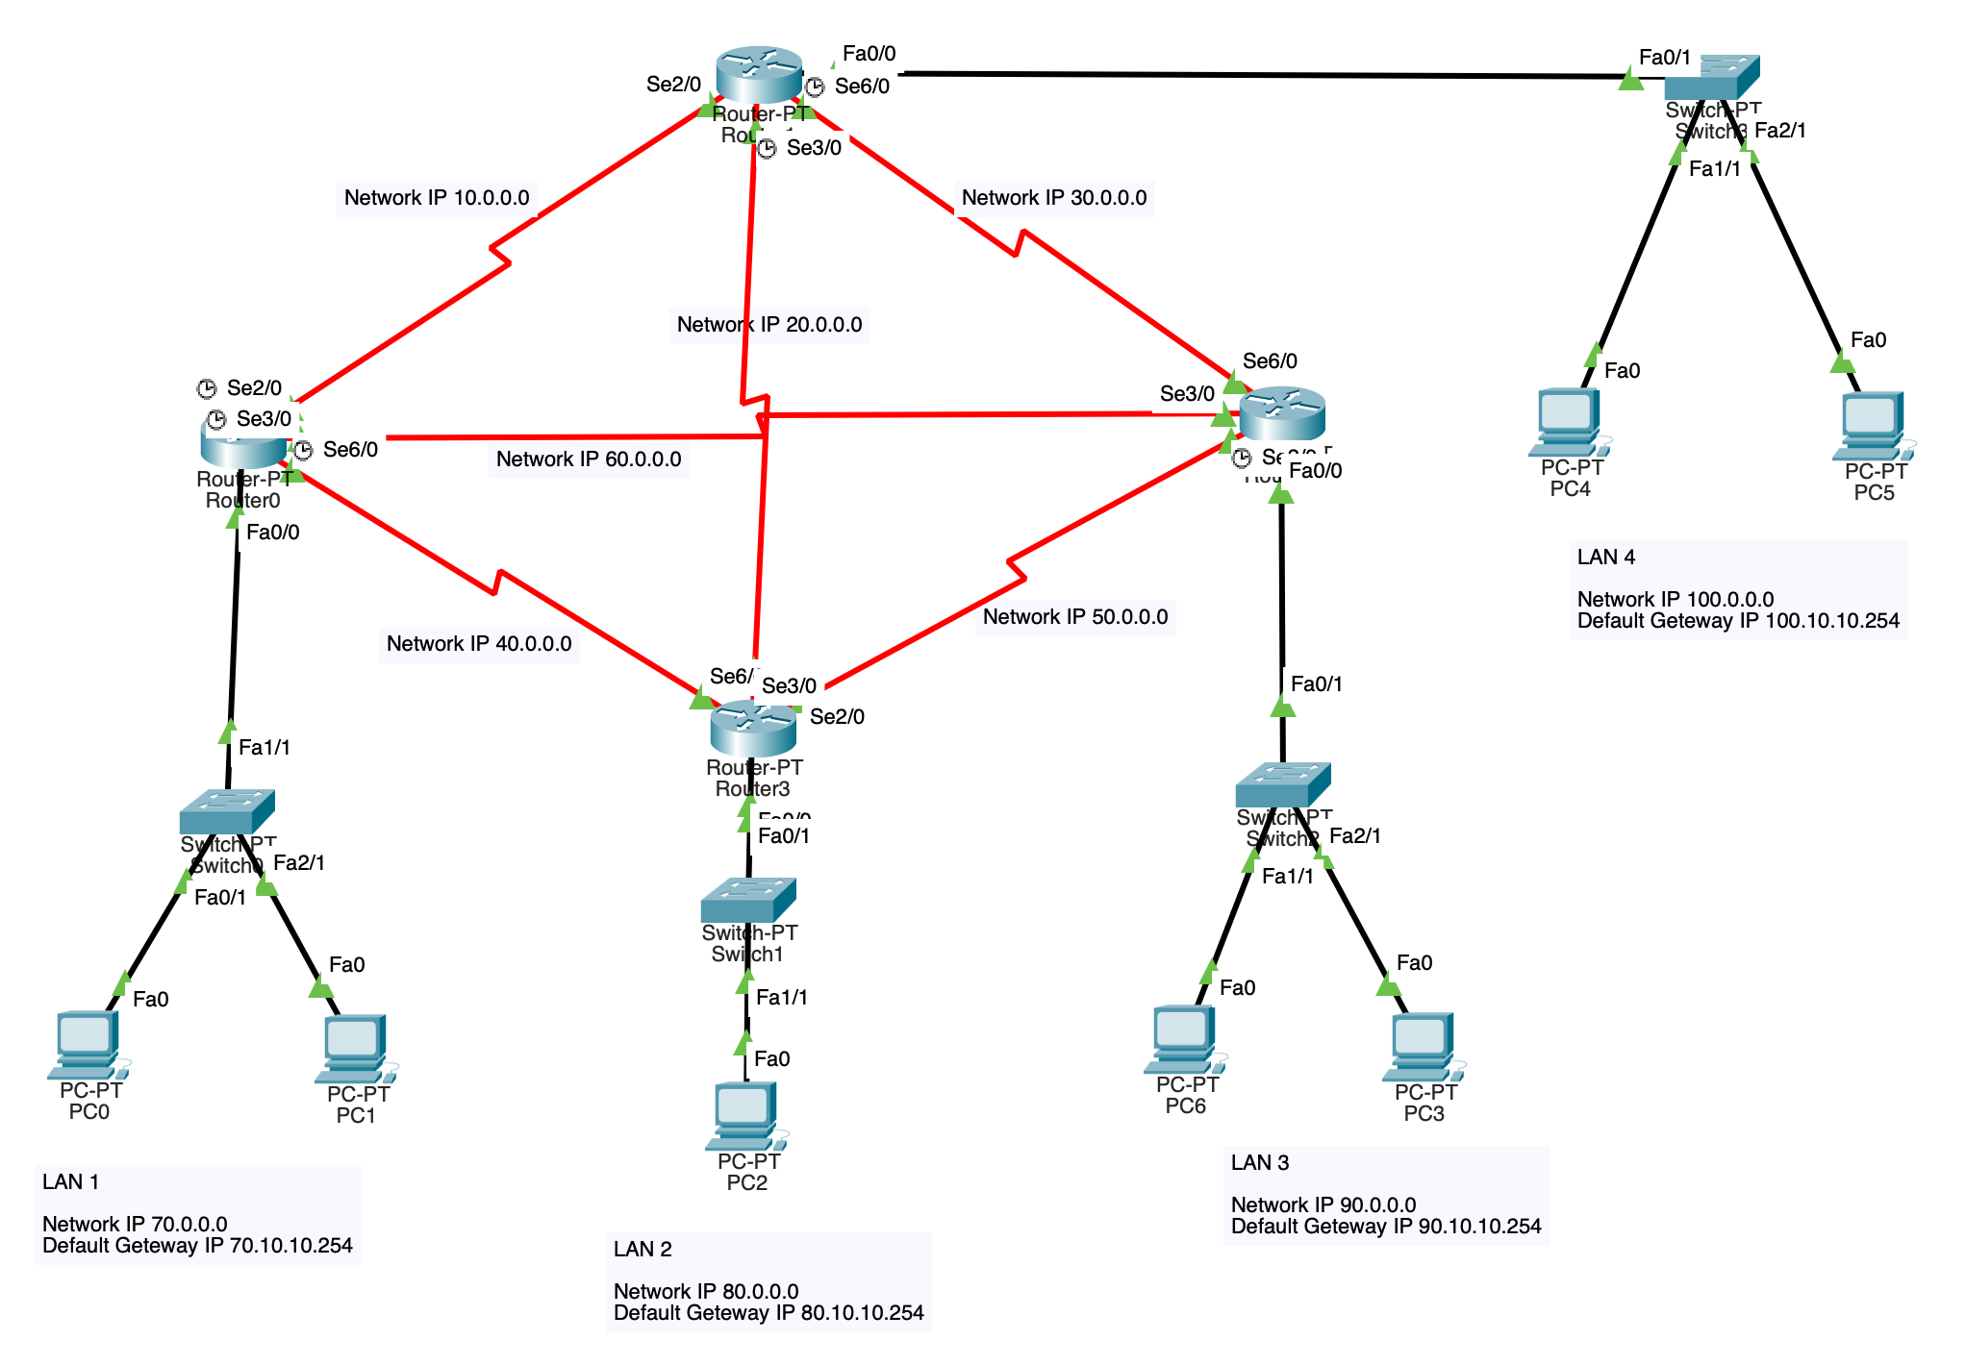

**Figure: Network Topology**

**Design and Configurations with Router**

**Router 0:**

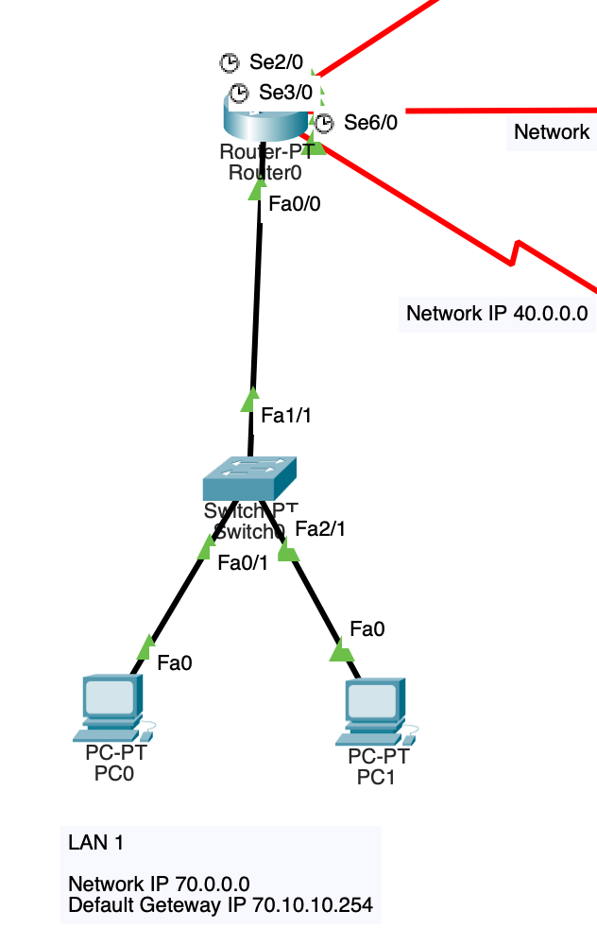

**Figure: Router 0**

interface fa0/0

ip address 70.10.10.254 255.0.0.0

no shut

do wr

exit

interface Se2/0

ip address 10.10.10.1 255.0.0.0

clock rate 6400

no shut

do wr

exit

interface Se3/0

ip address 60.10.10.1 255.0.0.0

clock rate 6400

no shut

do wr

exit

interface Se6/0

ip address 40.10.10.1 255.0.0.0

clock rate 6400

no shut

do wr

exit

**Router 1:**

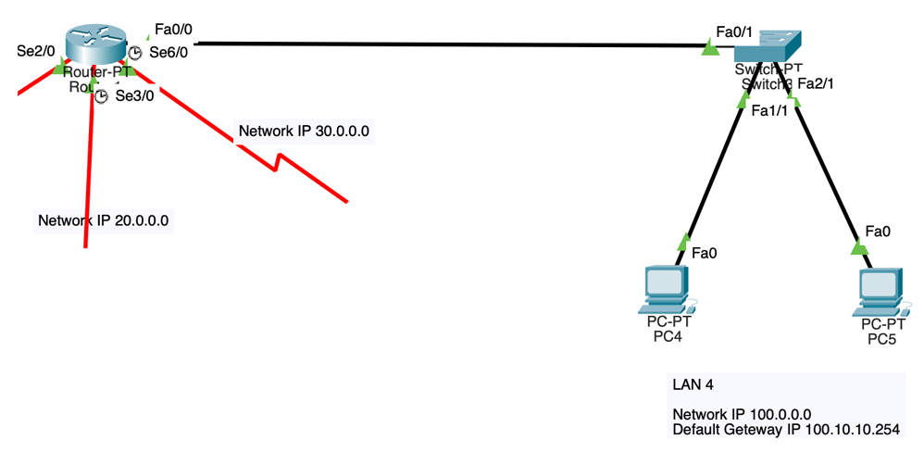

**Figure: Router 1**

interface fa0/0

ip address 100.10.10.254 255.0.0.0

no shut

do wr

exit

interface Se2/0

ip address 10.10.10.2 255.0.0.0

no shut

do wr

exit

interface Se3/0

ip address 20.10.10.1 255.0.0.0

clock rate 6400

no shut

do wr

exit

interface Se6/0

ip address 30.10.10.1 255.0.0.0

clock rate 6400

no shut

do wr

exit

**Router 2:**

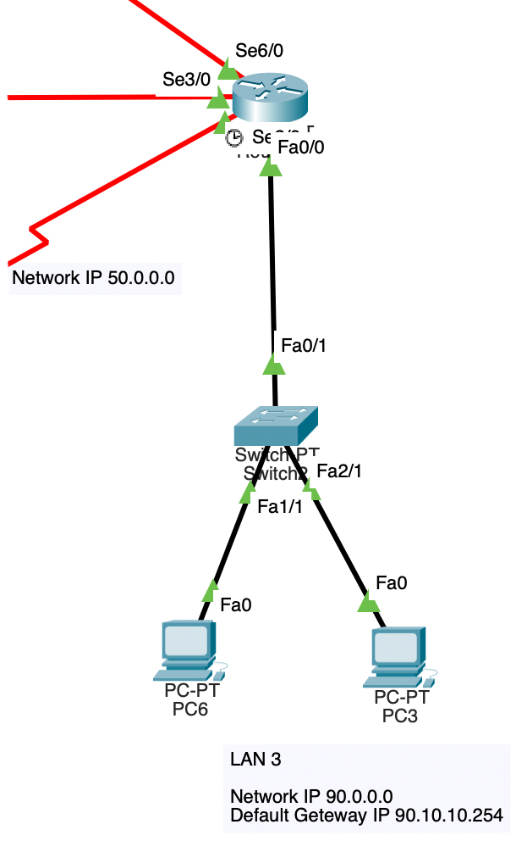

**Figure: Router 2**

interface fa0/0

ip address 90.10.10.254 255.0.0.0

no shut

do wr

exit

interface Se2/0

ip address 50.10.10.1 255.0.0.0

clock rate 6400

no shut

do wr

exit

interface Se3/0

ip address 60.10.10.2 255.0.0.0

no shut

do wr

exit

interface Se6/0

ip address 30.10.10.2 255.0.0.0

no shut

do wr

exit

**Router 3:**

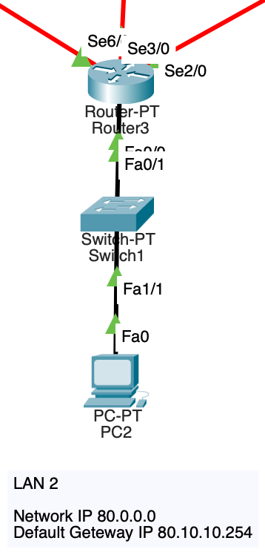

**Figure: Router 3**

interface fa0/0

ip address 80.10.10.254 255.0.0.0

no shut

do wr

exit

interface Se2/0

ip address 50.10.10.2 255.0.0.0

no shut

do wr

exit

interface Se3/0

ip address 20.10.10.2 255.0.0.0

no shut

do wr

exit

interface Se6/0

ip address 40.10.10.2 255.0.0.0

no shut

do wr

exit

**OSPF:**

**Router 0:**

router ospf 1

network 70.0.0.0 0.255.255.255 area 1

network 10.0.0.0 0.255.255.255 area 1

network 60.0.0.0 0.255.255.255 area 1

network 40.0.0.0 0.255.255.255 area 1

exit

**Router 1:**

router ospf 1

network 100.0.0.0 0.255.255.255 area 1

network 10.0.0.0 0.255.255.255 area 1

network 20.0.0.0 0.255.255.255 area 1

network 30.0.0.0 0.255.255.255 area 1

exit

**Router 2:**

router ospf 1

network 90.0.0.0 0.255.255.255 area 1

network 30.0.0.0 0.255.255.255 area 1

network 60.0.0.0 0.255.255.255 area 1

network 50.0.0.0 0.255.255.255 area 1

exit

**Router 3:**

router ospf 1

network 80.0.0.0 0.255.255.255 area 1

network 50.0.0.0 0.255.255.255 area 1

network 20.0.0.0 0.255.255.255 area 1

network 40.0.0.0 0.255.255.255 area 1

exit

**PING Operation:**

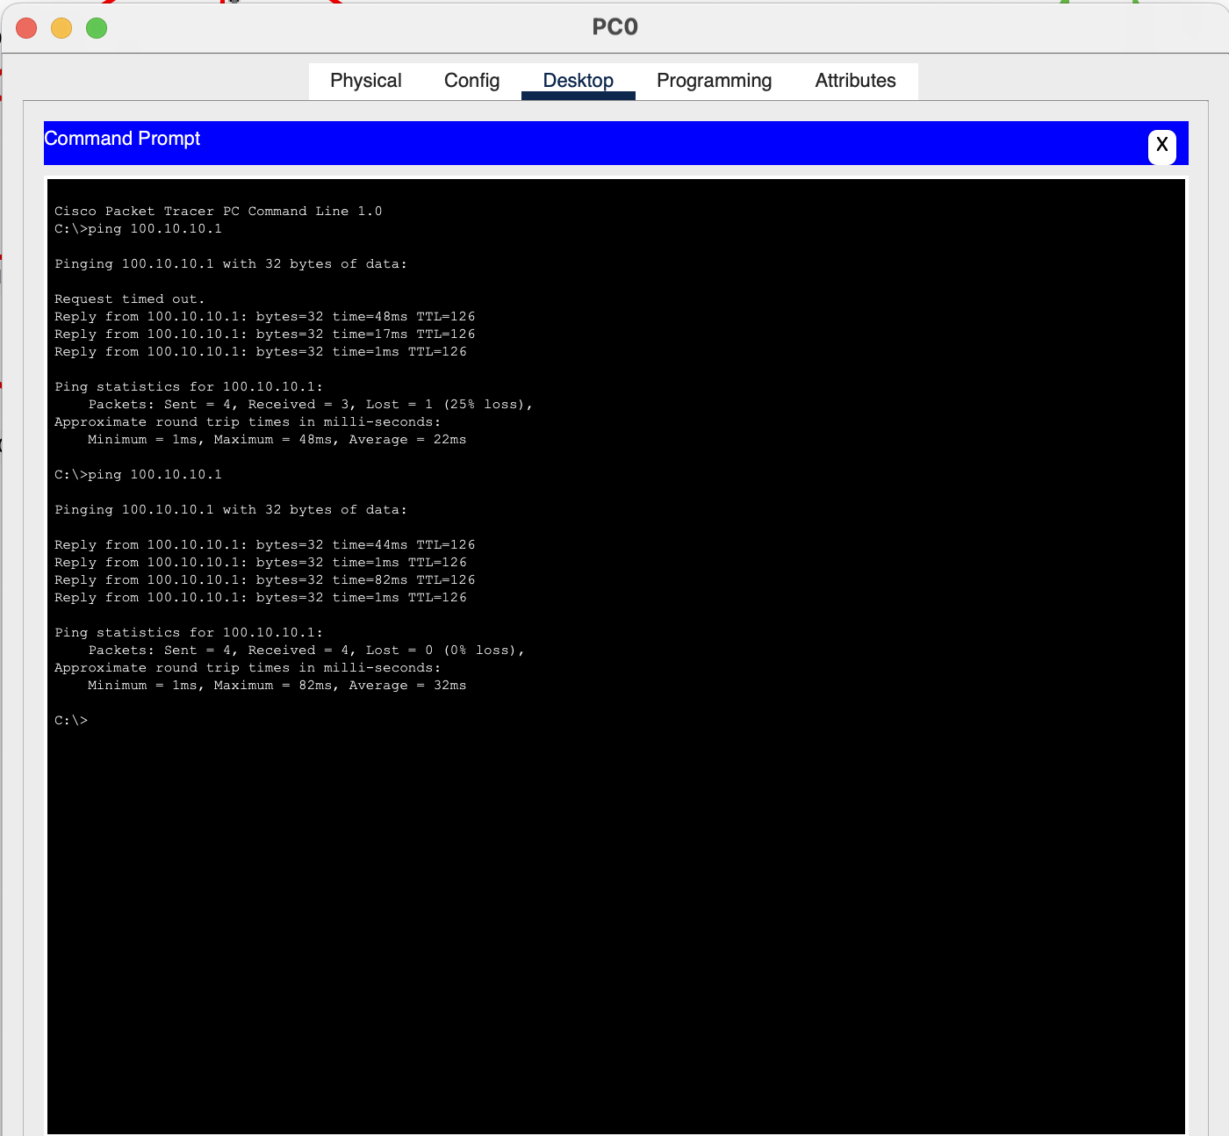

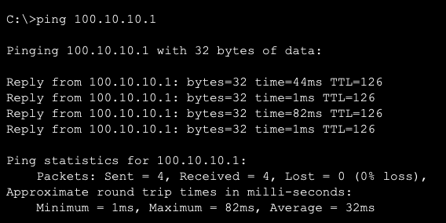

**Figure: PING operation between PC0 from Router0 and PC4 from Router1.**